Hands-On Lab

Introduction to Test Planning with Microsoft Test Manager 2012

Lab version: 11.0.50522.1 (RC)

Last updated: 6/7/2012

* + 1. 

Contents

Overview 3

Exercise 1: Creating and Configuring a Test Plan 4

Exercise 2: Adding Test Suites and Test Cases to a Test Plan 13

Exercise 3: Creating and Adding Requirements to a Test Plan 19

Overview

* 1. Microsoft Test Manager 2012 can be used to organize your test plans, author and manage your test cases, and run manual tests. In this lab you will be introduced to test planning in Microsoft Test Manager.
  2. This hands-on-lab is one out of a number of labs that deal with Microsoft Test Manager 2012. The recommended order to complete the labs in is as follows:
  + Introduction to Test Planning with Microsoft Test Manager 2012
  + Introduction to Test Case Management with Microsoft Test Manager 2012
  + Authoring and Running Manual Tests using Microsoft Test Manager 2012
  + Introduction to Platform Testing with Microsoft Test Manager 2012

# Prerequisites

In order to complete this lab you will need the Visual Studio 2012 virtual machine provided by Microsoft. For more information on acquiring and using this virtual machine, please see [this blog post](http://aka.ms/VS11ALMVM).

# Exercises

* 1. This hands-on lab includes the following exercises:
  2. Creating and Configuring a Test Plan
  3. Adding Test Suites and Test Cases to a Test Plan
  4. Creating and Adding Requirements to a Test Plan
  5. Estimated time to complete this lab: **60 minutes**.

Exercise 1: Creating and Configuring a Test Plan

* 1. In this exercise, you will learn how to create and configure a new Test Plan in Microsoft Test Manager. This test plan can be used, for instance, to test the new release of your software.
  2. Log in as **Julia**. All user passwords are **P2ssw0rd.**
  3. Open Microsoft Test Manager from **Start** | **All Programs** | **Microsoft Visual Studio 2012** | **Microsoft Test Manager**.
     1. **Note:** Microsoft Test Manager allows testers to work with test plans, author and organize manual test cases, execute test cases, file bugs, and post results back to Team Foundation Server.
  4. Select the activity center drop down from the top menu that currently shows Testing Center. The **Testing Center** is used to work with manual test cases and other general test case management. **Lab Center** is used to work with physical or virtual testing labs. For this lab, we will focus on the Testing Center.
     1. 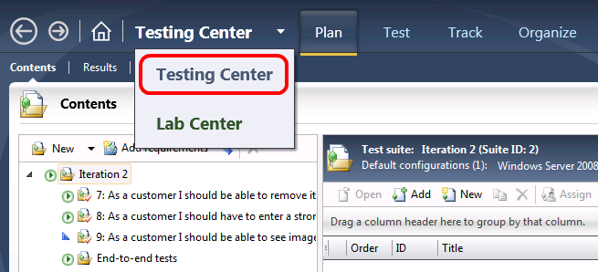
     2. Figure
     3. Testing Center showing the Plan activity
  5. If you are not in the Test plan view already, click on **Plan** from the main menu. The **Microsoft Test Manager** will connect to the most recently loaded test plan, which in the case of this virtual machine is the test plan named *Iteration 2*.
     1. 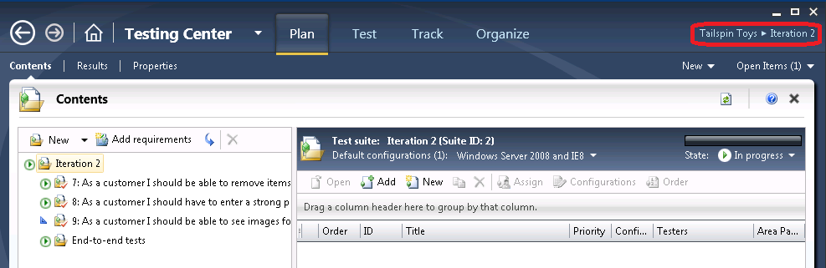
     2. Figure
     3. Test plan contents window for Iteration 2
  6. Select the **Home** button next to the activity center dropdown to open the **Testing Center** window.
     1. 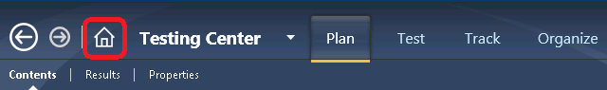
     2. Figure
     3. Open the Testing Center window using the Home button
  7. In the **Testing Center** window, select the **Add** button to open the **Add test plan** dialog box.
     1. 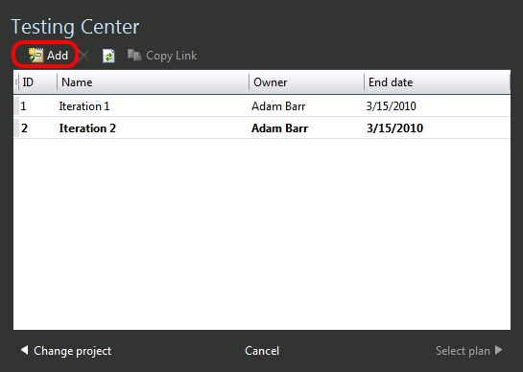
     2. Figure

Adding a new test plan

* 1. For **Plan name**, enter “**Release 2.0**”.
  2. For **Area path**, choose **Tailspin Toys\Web site.**
  3. For **Iteration**, choose **Tailspin Toys\Iteration 2**.
  4. Select the **Add** button to continue.
     1. 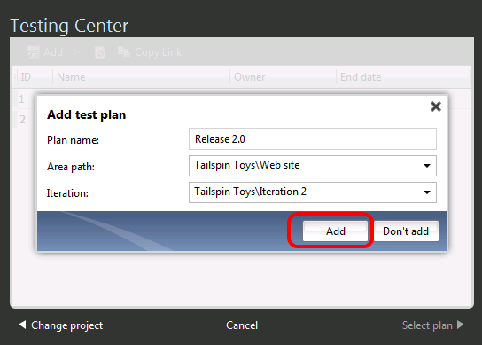
     2. Figure

Adding a new test plan

* 1. In the Testing Center window, select the newly created Release 2.0 test plan and then select the **Select Plan** button to open it.
     1. 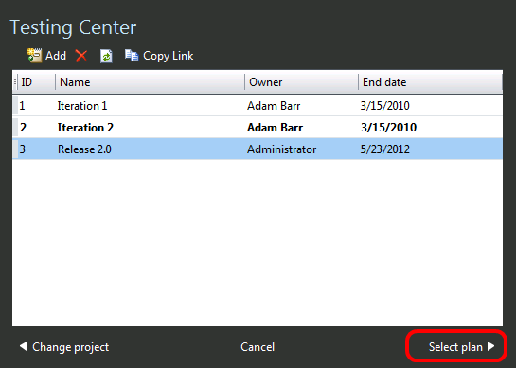
     2. Figure
     3. Selecting a test plan
  2. Select the **Properties** link to view the plan’s properties.
     1. 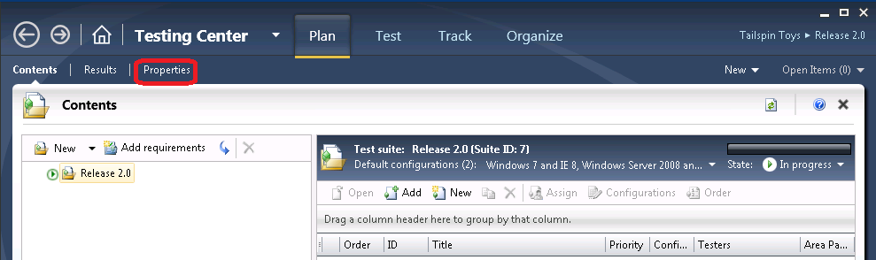
     2. Figure
     3. Testing Center showing new test plan
  3. The first section of the test plan properties window allows you to edit the basic properties like name, description, area path, iteration, state, and so on. The **Run Settings** section allows you to specify how manual and automated test runs should be setup, what test environment to use, and even the specific build to test against.
  4. For **Description**, enter “**Test plan for Tailspin Toys Web 2.0**”.
     1. 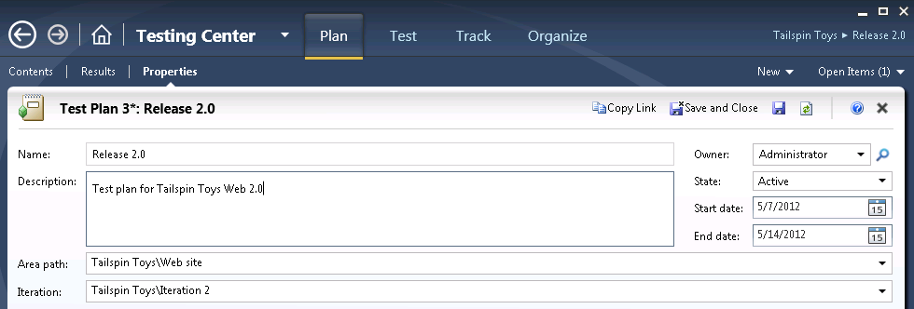
     2. Figure
     3. Test plan properties window
  5. In the **Manual Runs** section under **Run Settings**, choose **Lightweight Diagnostics** for the **Test settings** option and select the **Open** link to open the Test Settings window.
     1. 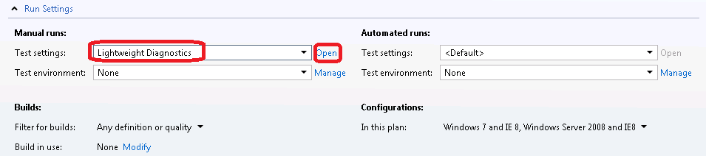
     2. Figure
     3. Adjusting manual test run settings
  6. In the test settings window, select the **Data and Diagnostics** step.
     1. 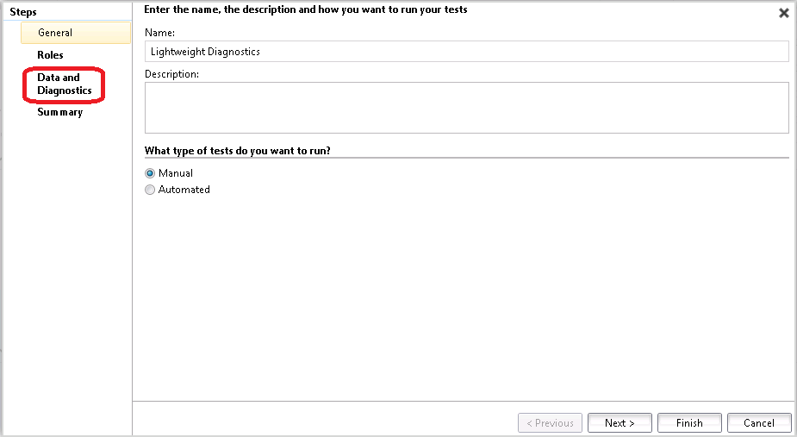
     2. Figure
     3. Test settings window
     4. **Note:** The Data and Diagnostics step for configuring test settings allows you to select which **Data Diagnostic Adapters** you want to utilize.
  7. Select the **Action Log,** **IntelliTrace, System Information,** and **Video Recorder** diagnostic data adapters (some may already be selected).
  8. Select the **Finish** button to close the test settings window and return to the test plan properties window.
     1. 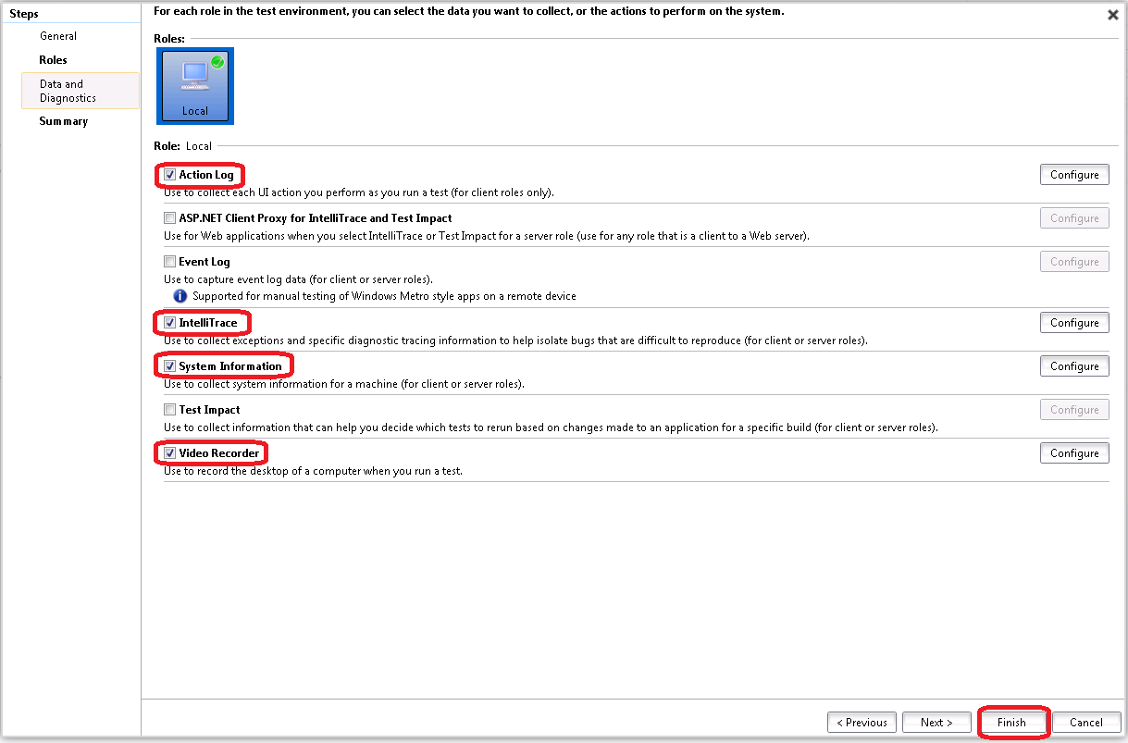
     2. Figure
     3. Configuring Data and Diagnostic adapters to use during tests
  9. Select the **Save** button to save the test plan.
     1. 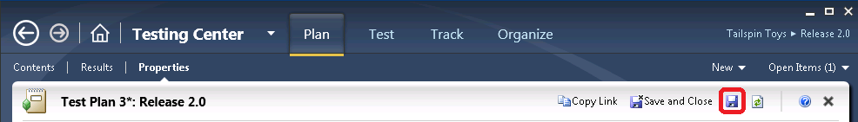
     2. Figure
     3. Location of Save button
     4. **Note:** The test plan needs to be saved before selecting a build.
  10. In the **Builds** section, select the **Modify** link next to the **Build in use** label. The selected build will be used when recording test results or filing bugs.
      1. 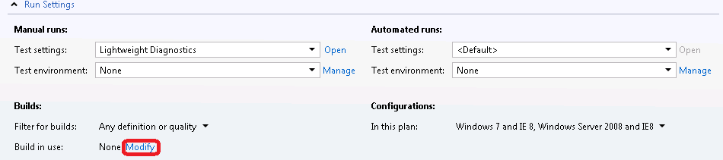
      2. Figure
      3. Selecting the build to use during test runs
  11. In the **Assign Build** window, select the first available build labeled **Tailspin Toys – Iteration 2_20100318.6 (Latest)** and select the **Assign to Plan** button.
      1. 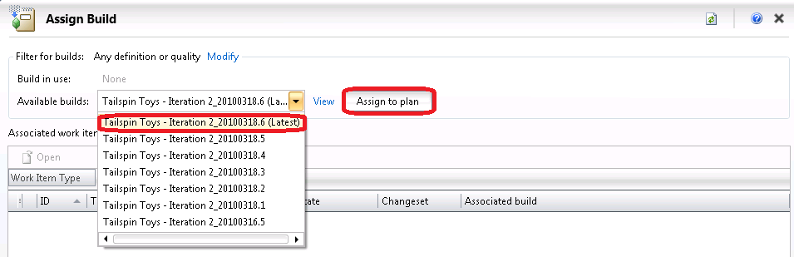
      2. Figure
      3. Assigning a build to the test plan
  12. Select the **Close** button () to exit the **Assign Build** window. Be careful not to close the main Test Manager window. This will bring you back the Test Plan properties window.
      1. 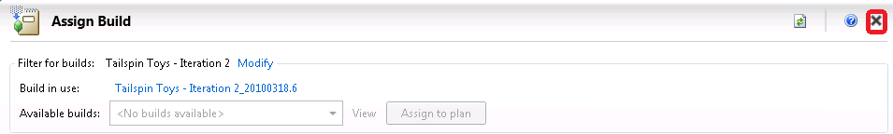
      2. Figure
      3. Location of Close button
  13. Test configurations describe which platforms to test against during test runs. In the **Configurations** section, select the drop down that currently shows “Windows 7 and IE 8, Windows Server 2008 and IE8” and select all available configurations.
  14. Select the **Apply** button to continue.
      1. 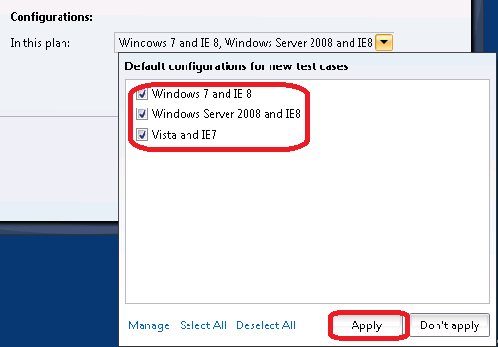
      2. Figure
      3. Location of Apply button
  15. Select the **Save and Close** button to save and close the new test plan.
      1. 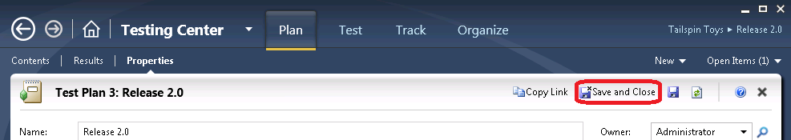
      2. Figure
      3. Location of Save and Close button

Exercise 2: Adding Test Suites and Test Cases to a Test Plan

* 1. In this exercise, you will learn how to add test suites and existing test cases to a test plan.
  2. In **Microsoft Test Manager**, select the **Plan** tab and select the **Contents** link to view the new **Release 2.0** test plan if it is not already open.
     1. 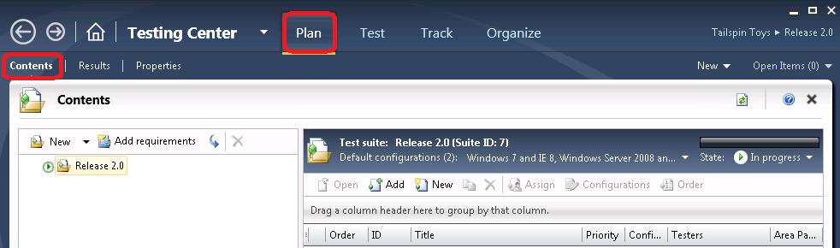
     2. Figure
     3. Test plan contents window for Release 2.0
  3. Create a manual test suite by right-clicking on the **Release 2.0** node and selecting the **New suite** option from the context menu.
     1. 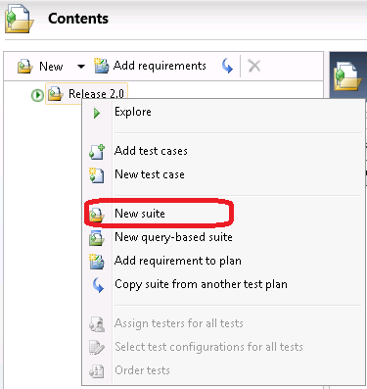
     2. Figure
     3. Creating a new test suite
  4. Enter **Regression Test** as the suite name and press the **Enter** key to accept.
     1. 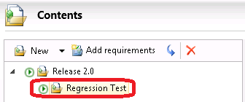
     2. Figure
     3. Providing a descriptive name for the new test suite
  5. Select the **Regression Test** suite in the left pane and select the **Add** button in the right pane to add existing test cases.
     1. 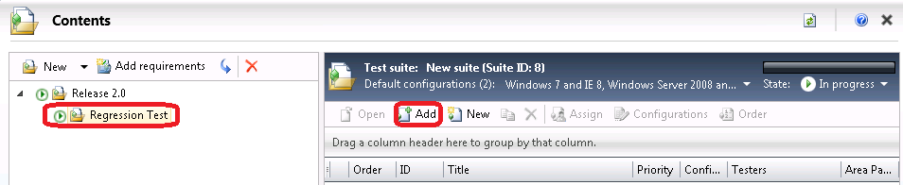
     2. Figure
     3. Location of the Add button
  6. In the **Add Test Cases to Suite** window, select the **Run** button to see all of the test cases for the current team project.
     1. 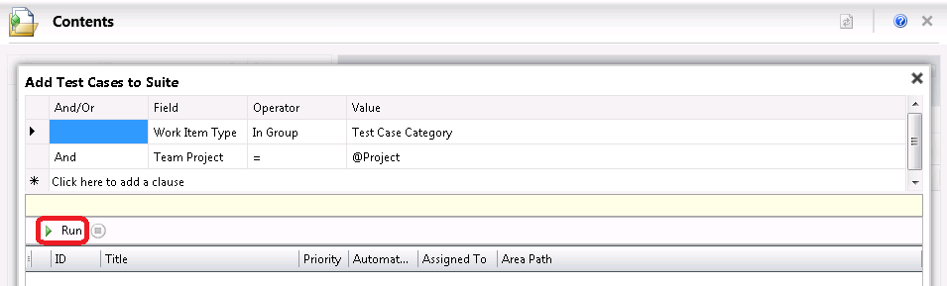
     2. Figure
     3. Run query to find test cases to add to new test suite
  7. Select test cases with **ID** = **40** and **41** and then select the **Add test cases** button to add them to the new **Regression Test** suite.
     1. 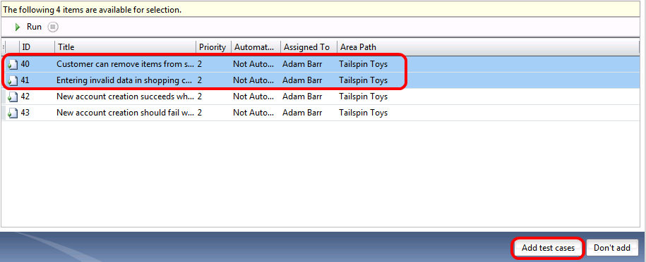
     2. Figure
     3. Adding test cases
     4. 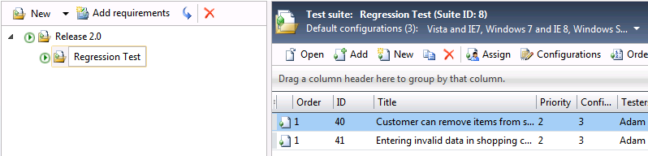
     5. Figure
     6. Test cases added to new test suite
  8. Now let’s add another type of test suite to the test plan. Right-click on the **Release 2.0** node and select **New query-based suite** from the context menu. Query-based test suites allow work item queries to be constructed in order to gather test cases, as you will see shortly.
     1. 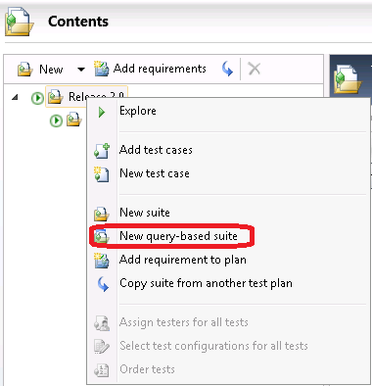
     2. Figure
     3. Adding a query-based test suite
  9. In the **Create a Query-Based Test Suite** window, enter **Tailspin Toys Suite** as the **Name**.
     1. 
     2. Figure
     3. Entering a name for the new test suite
  10. Select the grid row labeled **Click here to add a clause** (the row showing * at the beginning) to add a new query clause that restricts work items to those under the Tailspin Toys area path. Use the values shown in the following screenshot.
      1. 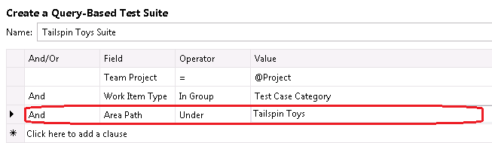
      2. Figure
      3. Creating query to select test cases
  11. Select the **Run** button to see the results of this query.
      1. 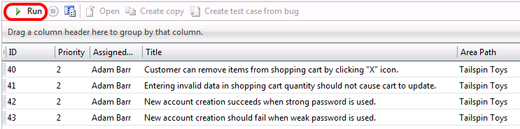
      2. Figure
      3. Location of Run button
  12. Select the **Create test suite** button to create this query-based test suite and return to the test plan contents window.
      1. 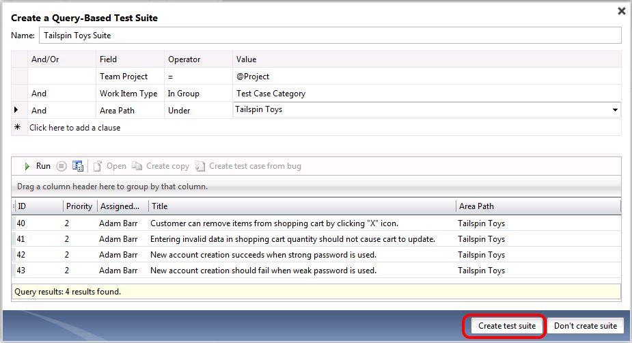
      2. Figure
      3. Location of Create test suite button
  13. You should now see that the **Release 2.0** test plan now has two test suites in it. The icon for the query-based test suite named **Tailspin Toys Suite** differs from the manual test suite named **Regression Test**. Query-based test suites dynamically determine test cases that are listed based on the defined query.
      1. 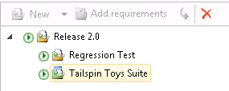
      2. Figure
      3. Test plan showing the two new test suites
      4. **Note:** In this lab environment, you will see a limited number of test cases. This may result in the re-use of test cases across multiple test suites.

Exercise 3: Creating and Adding Requirements to a Test Plan

* 1. In this exercise, you will learn how to create a new requirement and add that requirement to your test plan. You will also learn how to create a new test case for the new requirement.
  2. In **Microsoft Test Manager**, select the **Plan** tab and then select the **Contents** link to view the new **Release 2.0** test plan if it is not already open.
     1. 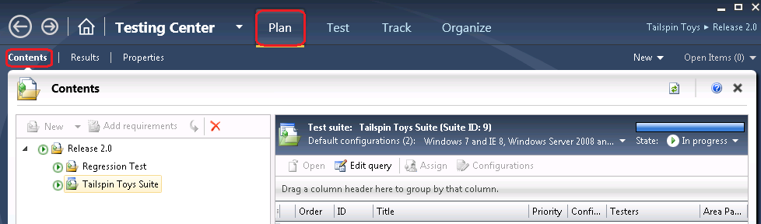
     2. Figure
     3. Test plan contents window for Release 2.0
  3. Create a new user story work item by selecting the **New** dropdown box and selecting **User Story**.
     1. 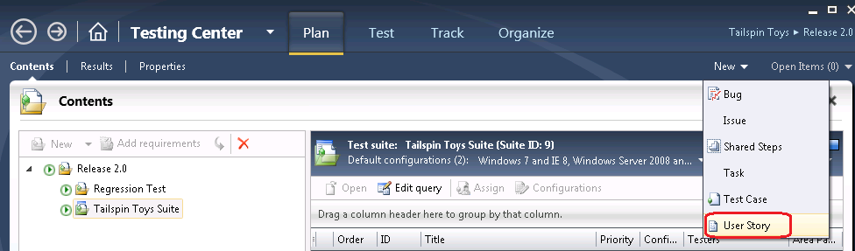
     2. Figure
     3. Creating new user story work item
  4. For the Title of the user story, enter “**As a consumer, I want to be able to add a coupon code to my purchase**”.
  5. For the **Risk** of the user story, select the “**2-Medium**” option from the dropdown box.
  6. Select the **Save and Close** button to continue.
     1. 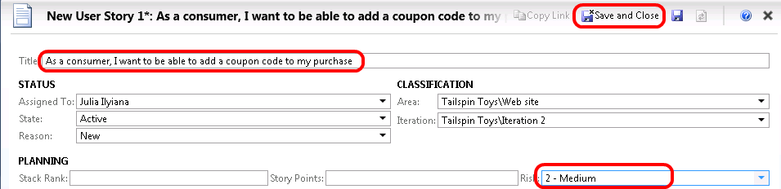
     2. Figure
     3. Define and save a new user story
  7. In the test plan contents window, select the **Release 2.0** node and then select the **Add requirements** button to add a new requirement to the plan.
     1. 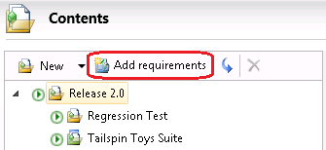
     2. Figure
     3. Adding a new requirement to the test plan
  8. In the window titled “**Add existing requirements to this test plan**”, select the **Run** button to see the results of this query. You should see the new user story that we just created.
     1. 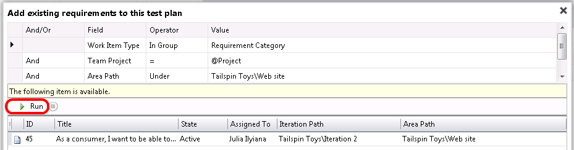
     2. Figure
     3. Adjusting the query to help find the recently created user story
  9. Select the user story (as a requirement) and then select the **Add requirements to plan** button. This will close the window and return to the test plan contents window.
     1. 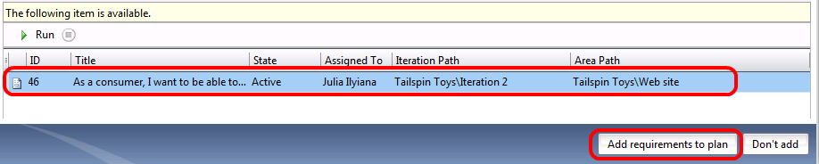
     2. Figure
     3. Selecting and adding the new user story as a requirement
  10. In the test plan contents window, you should now see the new requirement-based test suite listed. Its icon is different from the other two test suites to indicate that it is a requirement-based test suite. In the right pane, there are options to either link existing test cases or create new test cases.
  11. Select the **New** button in the right pane to create a new test case.
      1. 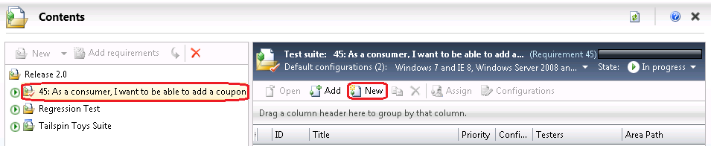
      2. Figure
      3. Creating a new test case for the user story requirement
  12. For the **Title** of the new test case, enter “**Add coupon code during checkout**”. Note that the **Area** and **Iteration** values in the **Classification** section have already been correctly pre-populated.
      1. 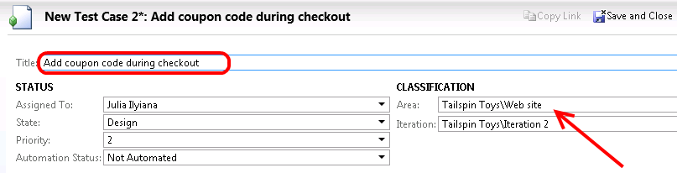
      2. Figure
      3. Creating new test case and assigning properties
  13. Enter the **Steps** for the new test case as shown in the screenshot below.
      1. 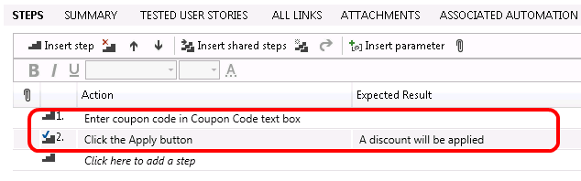
      2. Figure
      3. Creating steps for new test case
  14. Select the **Save and Close** button to save the new test case and return to the test plan contents window.
      1. 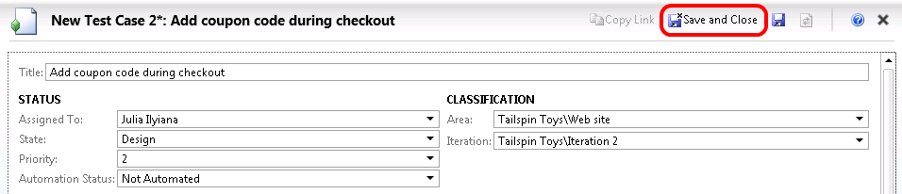
      2. Figure
      3. Location of Save and Close button
  15. In the test plan contents window, you should now see the new test case that was added to the requirement-based test suite.
      1. 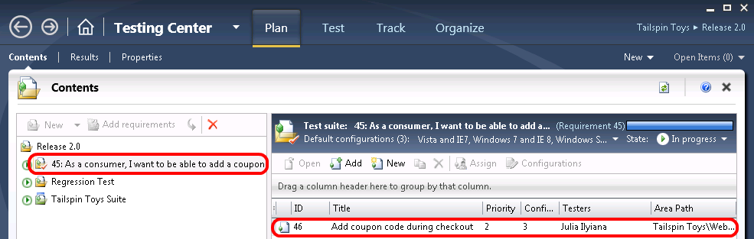
      2. Figure
      3. Requirement-based test suite showing the new test case

To give feedback please write to [VSKitFdbk@Microsoft.com](mailto:VSKitFdbk@Microsoft.com)

Copyright © 2012 by Microsoft Corporation. All rights reserved.